ربط التحصيلات بالعقود (عوضا عن عروض السعر)

كمرجع تم الاستناد على كل من (Hubspot) و (Salesforce) ولدينا الر سم ادناه يوضح النظام المتبع لكل منهما:

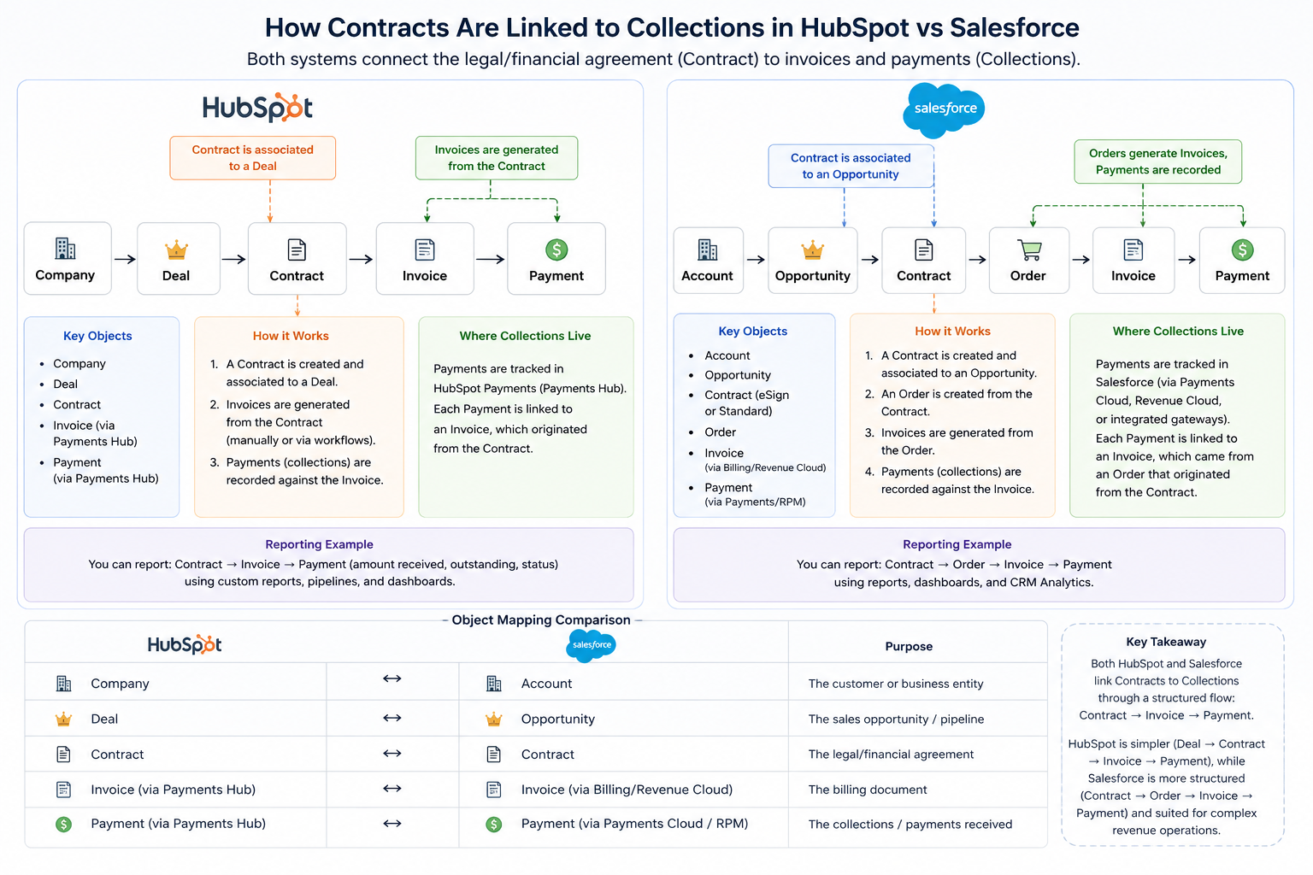
وبناءاً عليه نقترح ما يلي ليتم تطبيقه ضمن Reterra Boost

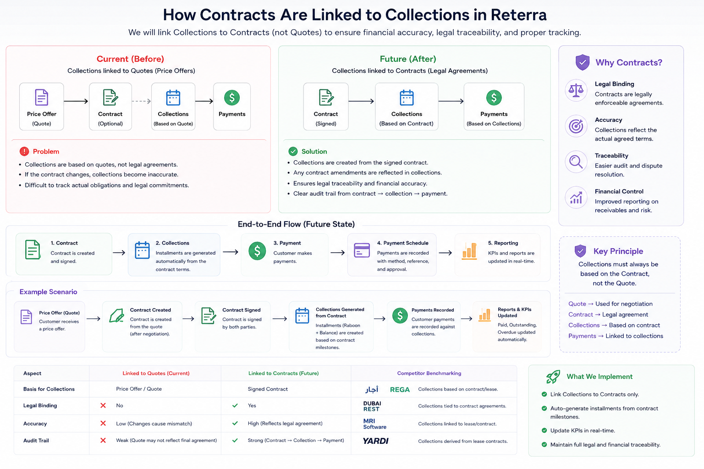

حسب اليوزر ستوري التالية

User Story: Linking All Collections to Contracts
Title: Collections Linked to Contracts for All Unit Types
User Story:
As a sales manager, finance executive, or product owner,
I want all collections (Off-Plan Sale, On-Plan Sale, On-Plan Rental) to be linked directly to the signed Contract,
so that all expected payments, actual payments, and KPIs are accurate and legally compliant, regardless of unit type.
Description:
- Previously, collections were linked to Price Quotes.
- Now, all collections for Off-Plan, On-Plan Sale, and On-Plan Rental units will reference the signed Contract.
- The Collections screen displays scheduled installments (upcoming or due).
- The Payment Schedule screen shows only payments actually received.
- KPIs (Total Paid, Outstanding, Overdue Amount, Risk Indicators) update automatically based on the Contract.
- Historical data must migrate to maintain correct links to contracts.
- Collections are displayed consistently across all system locations, with the same rules applied:
  - Collections Module / Collections & Paid Tab
  - Deal / Payments Tab
  - Property Details / Payments Tab
  - Customer Profile
Screen / Location:
- Boost → Collections → Collections Tab
- Boost → Collections → Payment Schedule Tab
Acceptance Criteria:
- Collections are now tied to Contracts for all unit types.
- Payment Schedule updates only for payments actually received.
- Statuses in Collections: Upcoming, Due, Overdue.
- Statuses in Payment Schedule: Paid (with payment details).
- Totals and KPIs reflect the correct stage (scheduled vs actual).
- Migration ensures existing collections linked to Quotes are correctly reassigned to Contracts.
- Users can filter, sort, and search efficiently by Unit, Contract, Status, or Date.
- Risk Indicators display overdue or due payments using color-coded flags.
Validation Rules:
- No payment can be marked Paid without confirmed Contract linkage.
- Due status applies to installments due today or within configurable threshold.
- Overdue status applies automatically after the due date.
- Totals must sum correctly across all units and installments.
- Installments cannot include rental payments if they belong to a sale contract, and vice versa.
Definitions:
Field Name | Type | Input Type | Required | Editable | Source | Description | Validation Rules
Contract ID | Text | Dropdown/System | Yes | No | CRM | Unique identifier of the signed Contract | Must exist
Unit Name | Text | Text | Yes | No | CRM | Name of the unit | Must exist
Installment # | Number | System | Yes | No | System | Sequential installment number | Unique per unit
Status | Enum | Dropdown | Yes | Yes | System | Upcoming / Due / Overdue / Paid… | Must follow defined statuses
Payment Amount | Currency | Number | Yes | Editable | User / Payment Gateway | Scheduled or received amount | >0
Due Date | Date | Date Picker | Yes | Yes | User | Scheduled installment date | Cannot be in the past on creation
Paid Date | Date | Date Picker | No | Yes | User / Payment Gateway | Actual payment date | Cannot precede creation
Total Paid | Currency | System | Yes | No | System | Sum of paid installments | Auto-calculated
Total Outstanding | Currency | System | Yes | No | System | Sum of unpaid installments | Auto-calculated
Overdue Amount | Currency | System | Yes | No | System | Sum of overdue payments | Auto-calculated
Notes:
- Applies to all unit types: Off-Plan Sale, On-Plan Sale, On-Plan Rental.
- Aligns with Salesforce & HubSpot best practices (payments linked to contracts).
- Ensures legal and financial accuracy, and proper KPI calculations.

